Supper at Emmaus
2010
Ally Sandoval
CIS 1020
11/18/2010
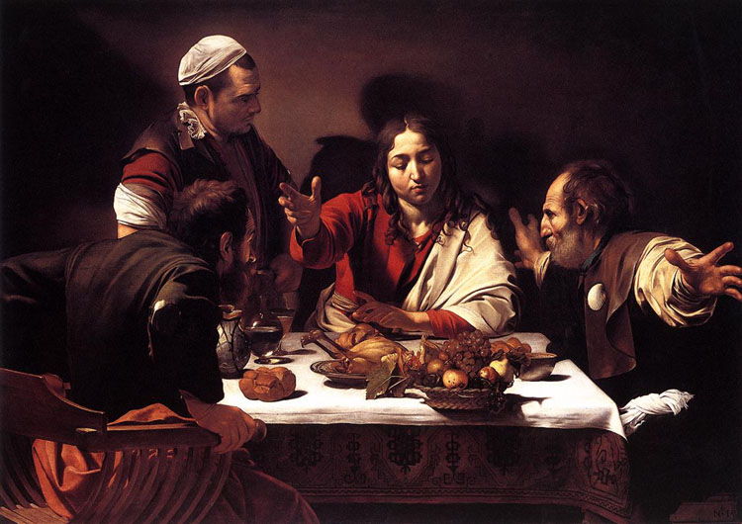

Supper at Emmaus, a painting of Jesus Christ by Michelangelo Merisi da Caravaggio (http://www.restoredtraditions.com), depicts a specific time in the life of Jesus Christ, the Son of God. At this point, Christ—also known as the Messiah, King of the Jews—is recognized by his fellow men at the last meal of the day (Version, The Holy Bible King James). This painting captures the reaction of the men surrounding Jesus, sitting at a table of food. It shows us that we should be ready to recognize Jesus the Christ, and to accept him as our Savior.

Overview
These men’s eyes had been blinded to the true sight of Jesus, until this moment caught in time. The main focus, other than Jesus, is the reaction held in each man’s attitude. All three of them are depicting a different emotion, obviously portraying their feelings toward Jesus and his revelation. The first man, on the left of the painting standing directly to Jesus’ right, has a very calm mannerism. He shows that he is ready to see Jesus as the true Savior, and willing to listen and accept what he has to tell them. The man sitting in front of the first man is sitting in a way that makes him look like he’s about to stand up. He clearly is showing unacceptance and an irritation because he is about to leave. This unacceptance is more of an ignorance, or an unwillingness to take in what Jesus might have to say. The last man, sitting on Jesus’ left, has his hands thrust out as if in an argument. He shows that not only is he unwilling to accept Jesus, he is angered by his revelation and will battle anything he has to say. These three emotions are common in the current era. It is how one might react to being introduced to the teachings of God and his Son. These men are typically portraying how others react to him in their own way.
Terms used in Art
Element | Example | Definition
Color | Warm, cool | The use of pigments
Light | The sun, shadows | Illumination from a particular source
Line | — | A continuous mark
Movement | Your eye following a river | The suggestion of motion
Shape | ◊ | The form of a closed line
Texture | Rough, smooth, bumpy | Visual and tactile quality of a surface

Element Analysis
The techniques analyzed:
- Color
- Light
- Movement
The colors in this painting are quite relevant to these men and their attitudes. Each man and Jesus is wearing an intense, eye-catching color among their clothes although it does not seem to consume them. Jesus is wearing his signature red clothing representing him as the true Savior revealed to the other men. The first man on Jesus’ right is also wearing red, a very advancing color. The second man in front of the first is wearing green, a somewhat receding color but intense enough to be noticeable. The third man with the outstretched arms is wearing a small amount of blue, the most receding color. Each man’s color coincides with his reaction, the warmer colors signifying their acceptance towards Jesus.
The light source in this painting starts from the area of the first man wearing red, and points directly toward Jesus. This also reinforces the fact that the first man has warmed up to him, showing that they are the only two directly within the line of light. With the light being directly on Jesus, and him wearing the most vivid red, he is the focal point of the painting. The light used is a soft light, which doesn’t make a large amount of contrast or harsh lines. This helps the harmony of the painting, keeping the three men important to the story also.
The movement of this piece is interesting, because it brings your eye downward as you move through the painting. It really forces your eyes to read this painting as you would a story, and unintentionally too. At the beginning, the painting is cluttered, the lines are moving in opposite directions and there are clusters of them. As you move along, you reach Jesus in the middle where his lines are mostly going in one direction and the colors decrease in variety. Near the end, you have a small area with very few colors and lines, and a large amount of unused space in the top half. This signifies the meaning of the story, how the men’s eyes were blind to Jesus and they might have felt a little chaotic not knowing who he was, but as they went along, they were awakened to the sight of him and things became more clear. The colors in the end of the painting are the most contrasting out of all, and might show how the men had divided their ways and became less united.

Comparison
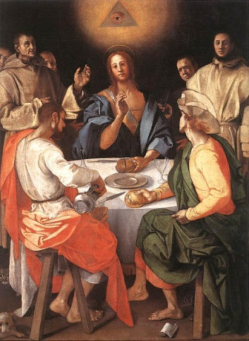
Another painting named Supper at Emmaus, by Jacopo Pontormo (http://freemasonry.bcy.ca), depicts a similar story of Jesus being recognized by his disciples. Although Pontormo painted his in 1525, and Caravaggio painted his in 1601, they are in similar styles, illustrating basically the same story with the same principles. Pontormo’s interpretation takes more of an abstract turn, using more people surrounding Jesus and a great variety of objects. Pontormo focuses most on telling how Jesus was recognized by how he broke the bread, while Caravaggio focuses on the men’s reactions. Pontormo includes an odd collection of faces, some being monks, some angry, and some of even different ethnicity. In this painting, a total of five of these people are looking at you while in the other, a total of zero are. Pontormo’s painting, with the majority of the people looking at you, focuses more on asking you the question of what you think rather than taking Caravaggio’s approach is more of, this is how it went and this is what happened. Both paintings still show the disciple’s differentiating reactions though.
Supper at Emmaus by Jacopo Pontormo
The major factor in Caravaggio’s painting is the fact that Jesus’ eyes are closed. This clearly shows how he was trying to disguise himself towards the men. The main focus of a person’s face is their eyes, and Jesus decided to hide his. If his disciples could not see his eyes, they had a slim chance of recognizing him. That is what is so clever; Caravaggio is leaving you, the viewer, to find the Savior for yourself. He wants you to know it is him and accept him on your own, without the need for Jesus to reveal himself.

Conclusion
Both paintings tell the story of Jesus and the Supper at Emmaus very effectively, but Caravaggio also asks more of you, being more effective than the previous. His painting asks us that we should be ready to recognize Jesus the Christ, and to accept him as our Savior.
Reasons why Ally is having a hard time with the numbered list:
- She has run out of relevant information
- She is having an even harder time trying to make something up
- She feels she has already gotten her point across

Other Versions of Supper at Emmaus
Han van Meegeren 1937 (www.artbible.info)
Rembrandt Harmensz 1648 (www.artbible.info)
Diego Rodriguez de Sylvia y Velasquez 1623 (www.metmuseum.org)
Bibliography

http://freemasonry.bcy.ca. <http://freemasonry.bcy.ca/art/emmaus.jpg>.

http://www.restoredtraditions.com. <http://www.restoredtraditions.com/images/products/detail/Caravaggio_Michelangelo_Merisi_da_The_Supper_at_Emmaus.jpg>.

Version, King James. The Holy Bible. 1327.
—. The Holy Bible King James. 1327.

