Ally Sandoval
Lynn Taylor
English 1010
13 September, 2011
Who is Paying Your Tuition?
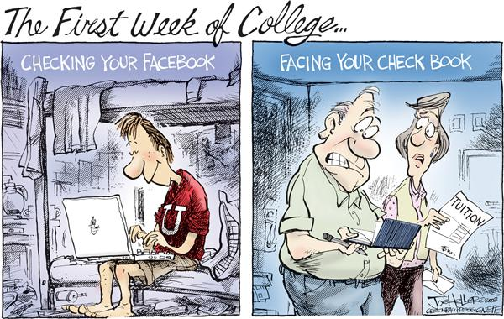
Is college tuition breaking your bank? It sure is breaking mine! Don’t worry, it hasn’t gone unnoticed; I found a political cartoon by Joe Heller called, “The First Week of College” (Heller). The cartoon contains two pictures, one of a student and the second of a couple. The student (who closely resembles a University of Utah student because of the red sweater he wears with a white ‘U’) is smiling while looking at his laptop. This picture is labeled, “Checking Facebook.” The parents are shown scoffing at their checkbook and a paper labeled ‘Tuition.’ This picture is labeled, “Facing Your Checkbook.” Joe Heller is successful in reaching his audience by showing how ridiculous tuition can be and the different effects it has on us.
None would know how bad tuition is other than a college student…except maybe their parents. Going into this cartoon, you would first have to know how much a secondary education might cost and who generally covers the cost. About 47 percent of full-time undergraduate students attend a public four-year college and the average cost of one year attended is just less than $9,000 (College Board). Heller’s cartoon is mainly focused towards those who either have or are anticipating this experience of college tuition. He is implying in this particular circumstance that the parents are expected to foot the bill while the students breeze by without paying attention. He is particularly pointing a finger at Facebook, a popular social website, as the culprit of an unfocused student population. Is it possible that he suggesting that something be done about this?
Judging by the fact that Heller didn’t include specific references to any sort of institution, he wasn’t really saying that college expenses are too high. His purpose was to show the relationship between the parents and their student. Maybe students are not focusing their attention enough on the important things such as tuition. Maybe they should not just pass the responsibilities on and let their parents foot the bill. He is not necessarily saying that something should be done, but bringing light to the fact that the students should be valuing their education more (especially if it’s being paid for).
Heller made his point in his cartoon by specifying certain things. He brought the characters to life with vivid colors while subduing the background. He didn’t really finish sketching the objects surrounding the characters because they are somewhat unimportant. His play on words was clever and the main point of the cartoon, that’s why he made them easily visible and uninterrupted. The expression on the characters’ faces also exaggerates his intended emotions for them. Heller was effective in the ways he portrayed his cartoon.
This message is easily understood and could very well reach out to the audiences he intended. Seeing as the parents would be the one with the thorn in their side about paying tuition, it is very likely they would notice it in a newspaper or on a website they were browsing. It is simple and eye catching, not to mention funny! It appeals to Logos because yes, it is a fact that college tuition can be expensive if you do not receive the right support. It appeals to Pathos because parents might become seriously angry if their children didn’t appreciate what they did for them in hopes of them becoming a good student. It also kind of appeals to Ethos because Facebook is such a common website among young adults. Just over half of the active Facebook users are young adults ages 18-34, those who are college age (Smith). It doesn’t completely appeal to Kairos because tuition has been around just as long as colleges have.
I particularly enjoyed Joe Heller’s “First Week of College” cartoon because I thought it was funny, effective, and I could almost relate to it. Even though I receive financial aid and pay for my own books and fees, I understand where he is coming from and I definitely spend a lot of time on Facebook. I have checked it four times since starting this paper.

Works Cited
Heller, Joe. The Cagle Post, College Costs, The First Week of College. Sep 2011. Web 1

Sep. 2011.

The College Board. What it Costs to Go to College. 2011. Web. 1 Sep. 2011.
Smith, Justin. Facebook Statistics, College Students’ Facebook Use Easing Up Over The

Summer While Parents Logging On in Record Numbers, 6 July 2009. Web. 5 Sep.

2011

